**Frontend Development with React.js**

**Project Documentation**

**Introduction**

* **Project Title** : COOK BOOK : Your Virtual Kitchen Assistent
* **TEAM ID** : NM2025TMID47608
* **TEAM LEADER** : HARIHARAN S
* **ROLE** : CODE AND DEVELOPMENT
* **TEAM MEMBER** : SATHISH K
* **ROLE** : CODE AND DEVELOPMENT
* **TEAM MEMBER** : KANNAN G
* **ROLE** : DEMO VIDEO
* **TEAM MEMBER** : KARTHICK M
* **ROLE** : DOCUMENT

# Project Overview

* **Purpose**: The purpose of the Cookbook is to provide users with a comprehensive virtual kitchen assistant that helps them plan, organize, and execute meals with ease. The Cookbook aims to make cooking and meal planning more efficient, enjoyable, and accessible to users of all skill levels.
* **Features**: 1. Recipe Library: A vast collection of recipes with ingredients, instructions, and cooking times.
* 2. Meal Planning: A feature that generates meal plans based on user preferences and dietary needs.
* 3. Grocery List Generator: A tool that creates grocery lists based on meal plans and recipes.
* 4. Cooking Tips and Techniques: A library of cooking tips, techniques, and guides.
* 5. Nutrition Information: A database of nutritional information for common ingredient

# Architecture

1. Recipe Database: A comprehensive database of recipes with ingredients, instructions, and cooking times.
2. Meal Planning Module: A module that generates meal plans based on user preferences and dietary needs.
3. . Grocery List Generator: A tool that creates grocery lists based on meal plans and recipes.
4. . Cooking Tips and Techniques: A library of cooking tips, techniques, and guides.
5. . Nutrition Information: A database of nutritional information for common ingredients and meals.

# .Setup Instructions

* 1. Create a Profile: Create a user profile to save preferences and dietary needs. o 2. Explore Recipes: Browse the recipe database and save favorite recipes.
* 3. Generate Meal Plans: Use the meal planning module to generate meal plans based on user preferences and dietary needs.
* 4. Create Grocery Lists: Use the grocery list generator to create lists based on meal plans and recipes.
* 5. Access Cooking Tips and Techniques: Access the library of cooking tips, techniques, and guides
* **Prerequisites**: List software dependencies (e.g., Node.js).
* **Installation**: Provide a step-by-step guide to clone the repository, install dependencies, and configure environment
* **Local State**: Explain the handling of local states within components.

# User Interface

o Provide screenshots or GIFs showcasing different UI features, such as pages, forms, or interactions.

# Styling

* **CSS Frameworks/Libraries**: Describe any CSS frameworks, libraries, or preprocessors (e.g., Sass, Styled-Components) used.
* **Theming**: Explain if theming or custom design systems are implemented.

# Testing

* **Testing Strategy**: Describe the testing approach for components, including unit, integration, and end-to-end testing (e.g., using Jest, React Testing Library).
* **Code Coverage**: Explain any tools or techniques used for ensuring adequate test coverage.

**Folder structer**:

. Recipes: A folder containing recipe files with ingredients, instructions, and cooking times.

1. Meal Plans: A folder containing meal plan files with generated meal plans.
2. Grocery Lists: A folder containing grocery list files with ingredients and quantities.
3. Cooking Tips and Techniques: A folder containing files with cooking tips, techniques, and guides.
4. Nutrition Information: A folder containing files with nutritional information for common ingredients and meals. **Running Application**
5. **Launch the Application: Open the Cookbook application on your device.**
6. **Navigate to the Dashboard: Access the dashboard to view meal plans, recipes, and grocery lists.**
7. **Explore Recipes: Browse the recipe library and save favorite recipes.**

# Screenshort or demo

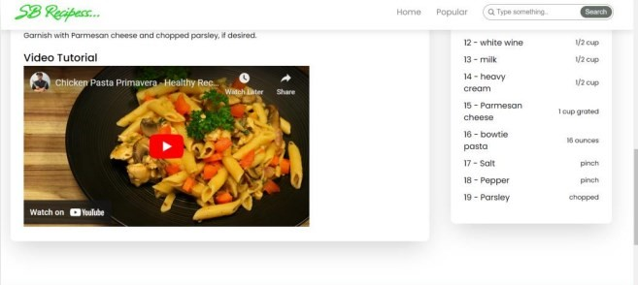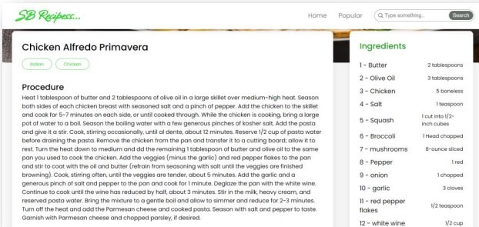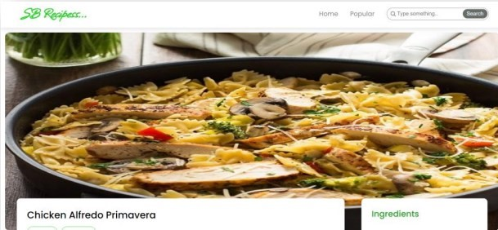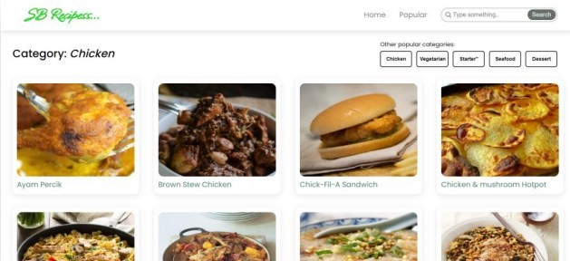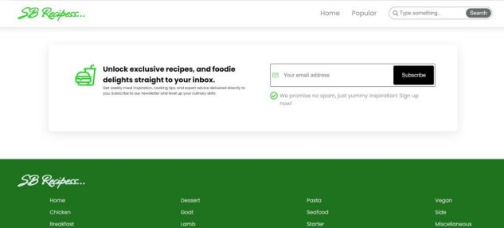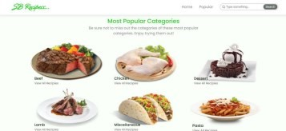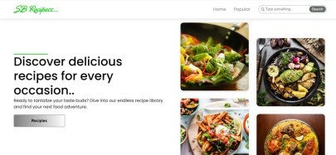

# Known Issues

Voice Recognition Issues: AI assistants may struggle with accents, background noise, or multiple users speaking at once.

* Data Privacy Concerns: Smart kitchen devices collect and store user data, raising security concerns.
* High Costs: Many AI-powered kitchen appliances come with a hefty price tag, limiting widespread adoption.
* Limited Integration: Limited integration with external services, such as grocery delivery or meal kit services.

# Future Enhancements

Enhanced AI Personalization: AI will offer more tailored recipe suggestions based on real-time health tracking.

* Deeper Integration with Smart Homes: AI will seamlessly connect kitchens with other smart home devices.
* AI-Powered Cooking Robots: Fully automated robotic chefs may become a reality in household kitchens.
* Sustainable Cooking Solutions: AI will help minimize food waste by optimizing ingredient usage and meal portions.
* Advanced Meal Planning: AI will generate meal plans based on user preferences, dietary needs, and ingredient availability.

**DEMO VIDEO LINK**

**https://drive.google.com/file/d/1Etvi4Mpc20m-vEHp7ZpwBhh2ZjI4Xipw/view?usp=drivesdk**